Test Case: tc002_SPX_Dev5_Crear_Requisicion_Spot_Con_FAD_Tipo_Cobro_CC
Step 1 - Enter username and password and click to button Enter : Credentials Entered
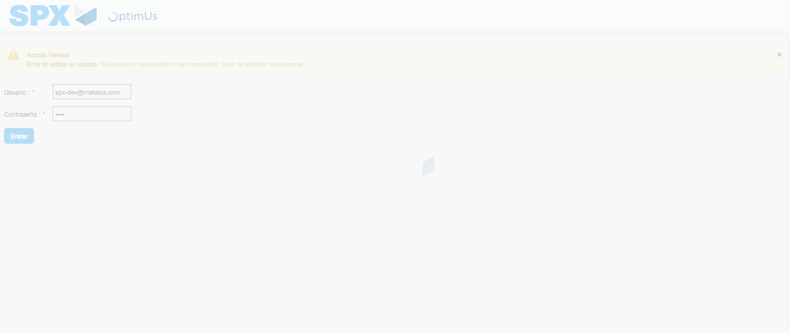Image file-name: QC_Testing-tc002_SPX_Dev5_Crear_Requisicion_Spot_Con_FAD_Tipo_Cobro_CC-1789485301330

Step 2 - Select to UEN and Access to Spot Buy Requisitions : UEN Correctly selected and Correct access
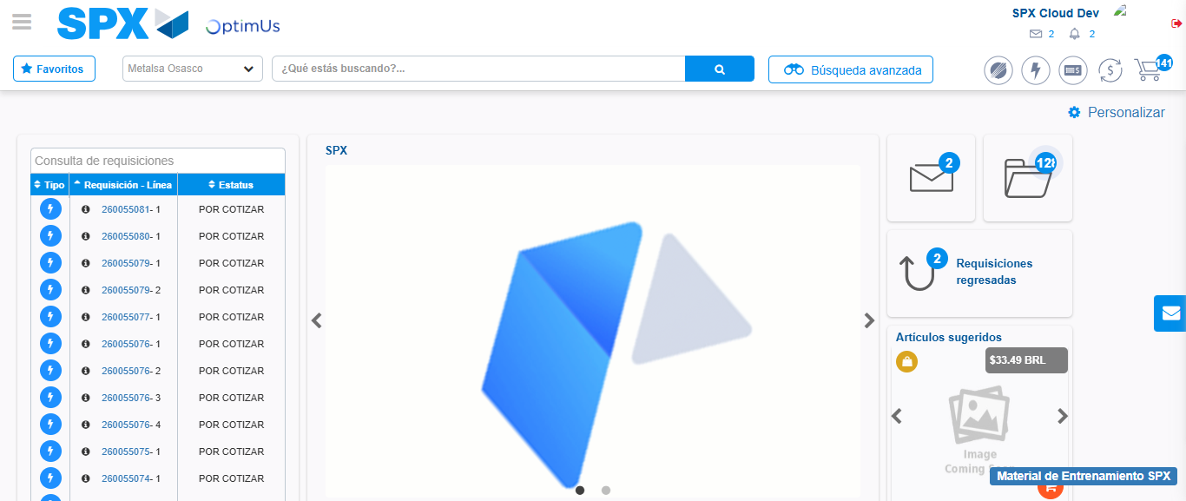Image file-name: QC_Testing-tc002_SPX_Dev5_Crear_Requisicion_Spot_Con_FAD_Tipo_Cobro_CC-1789485324635

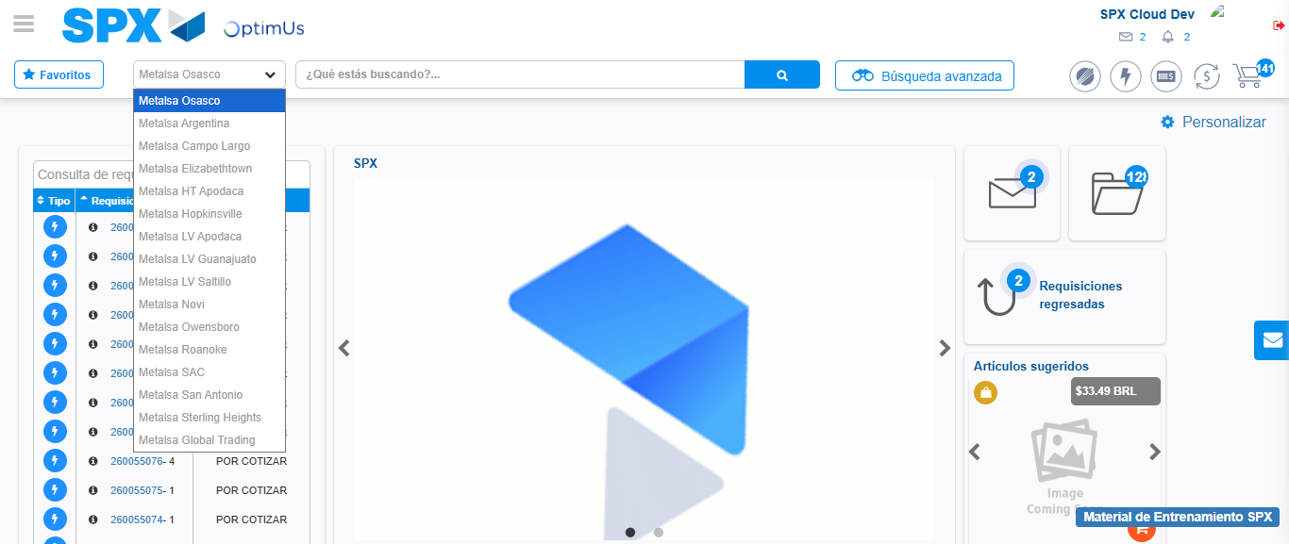Image file-name: QC_Testing-tc002_SPX_Dev5_Crear_Requisicion_Spot_Con_FAD_Tipo_Cobro_CC-1789485325210

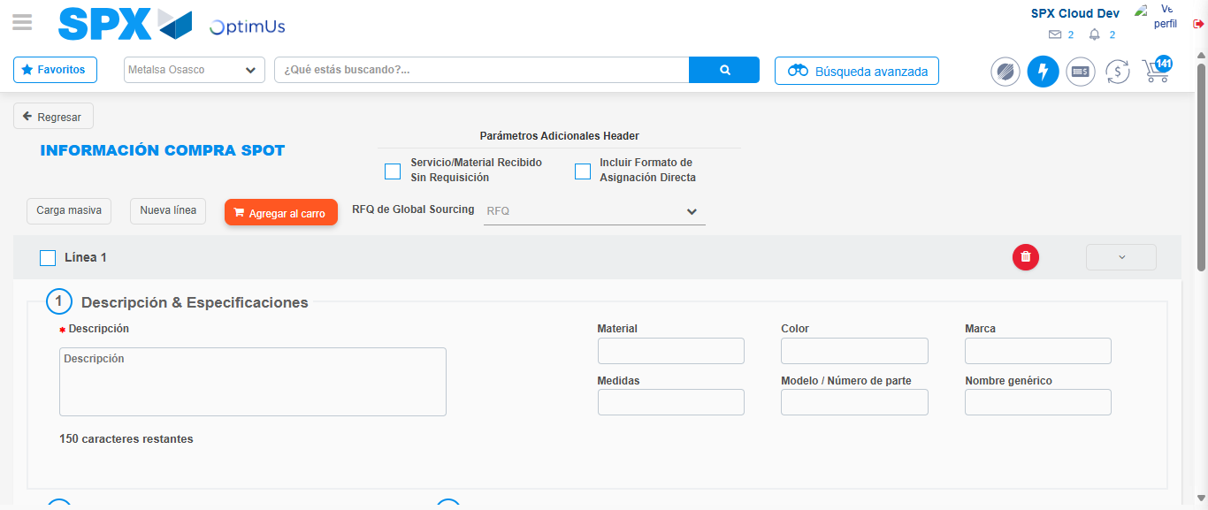Image file-name: QC_Testing-tc002_SPX_Dev5_Crear_Requisicion_Spot_Con_FAD_Tipo_Cobro_CC-1789485330016

Step 3 - Add FAD to Requisition: FAD Successfully Added
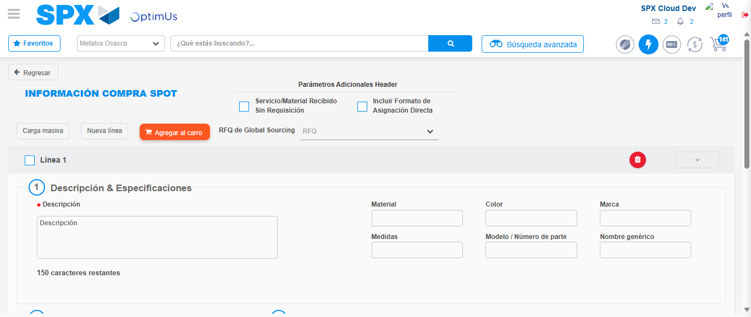Image file-name: QC_Testing-tc002_SPX_Dev5_Crear_Requisicion_Spot_Con_FAD_Tipo_Cobro_CC-1789485330311

Image file-name: QC_Testing-tc002_SPX_Dev5_Crear_Requisicion_Spot_Con_FAD_Tipo_Cobro_CC-1789485330514

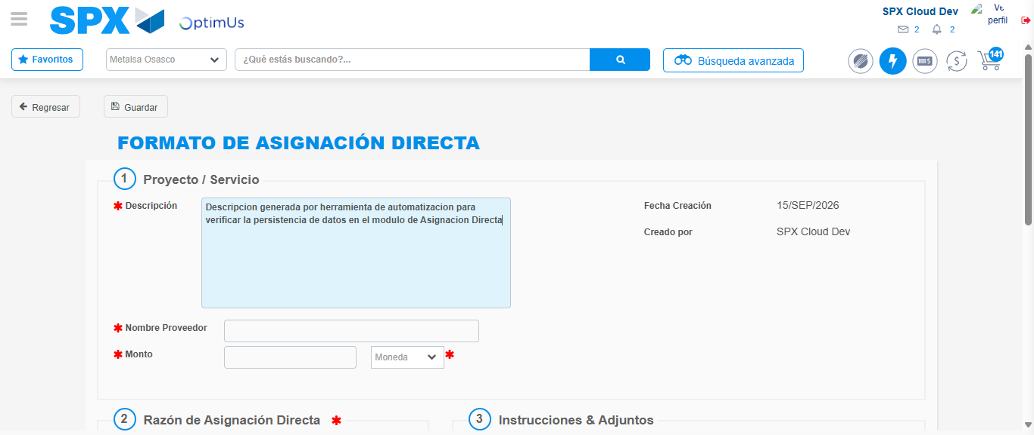Image file-name: QC_Testing-tc002_SPX_Dev5_Crear_Requisicion_Spot_Con_FAD_Tipo_Cobro_CC-1789485333386

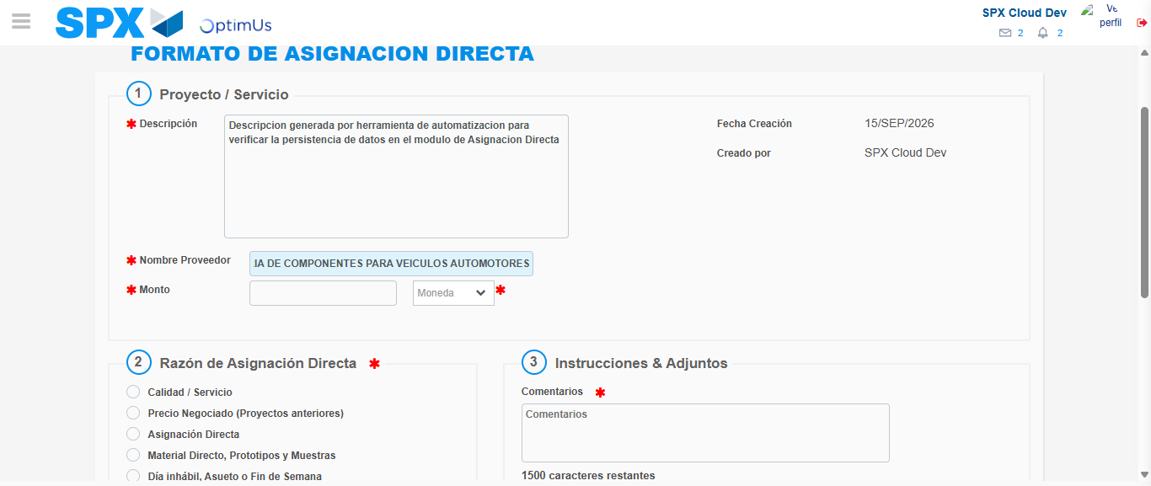Image file-name: QC_Testing-tc002_SPX_Dev5_Crear_Requisicion_Spot_Con_FAD_Tipo_Cobro_CC-1789485342379

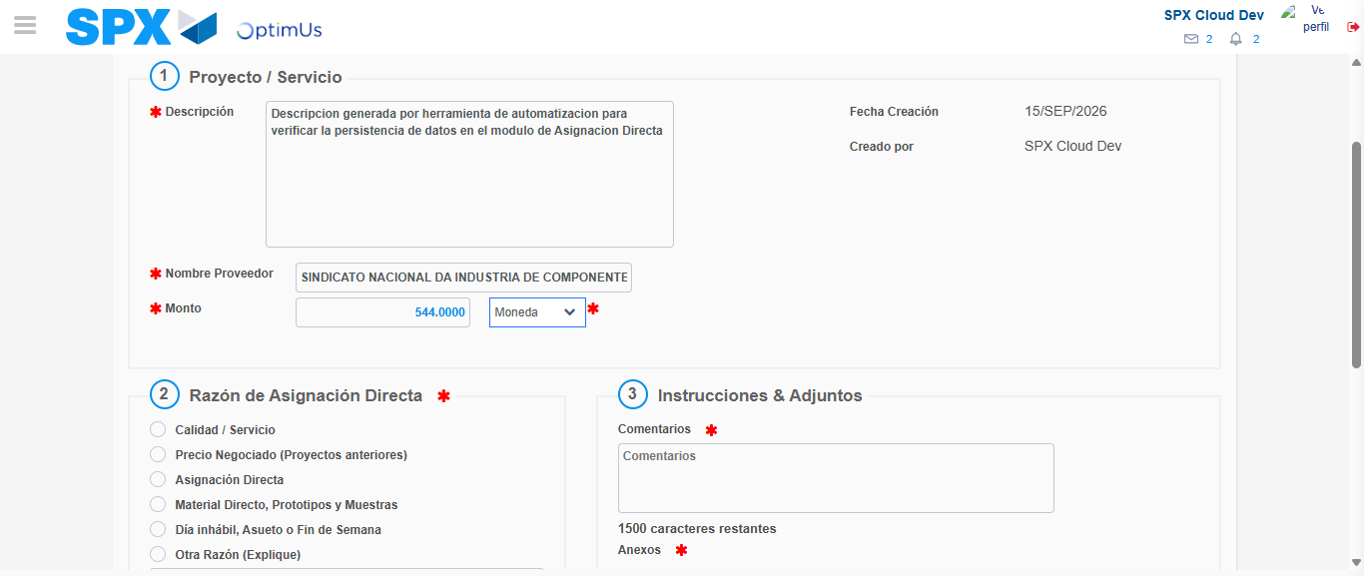Image file-name: QC_Testing-tc002_SPX_Dev5_Crear_Requisicion_Spot_Con_FAD_Tipo_Cobro_CC-1789485342824

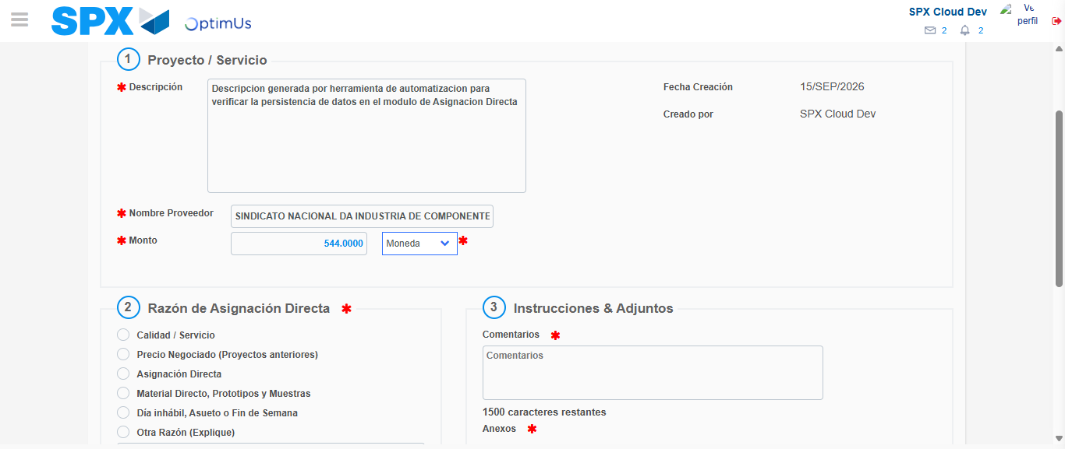Image file-name: QC_Testing-tc002_SPX_Dev5_Crear_Requisicion_Spot_Con_FAD_Tipo_Cobro_CC-1789485343076

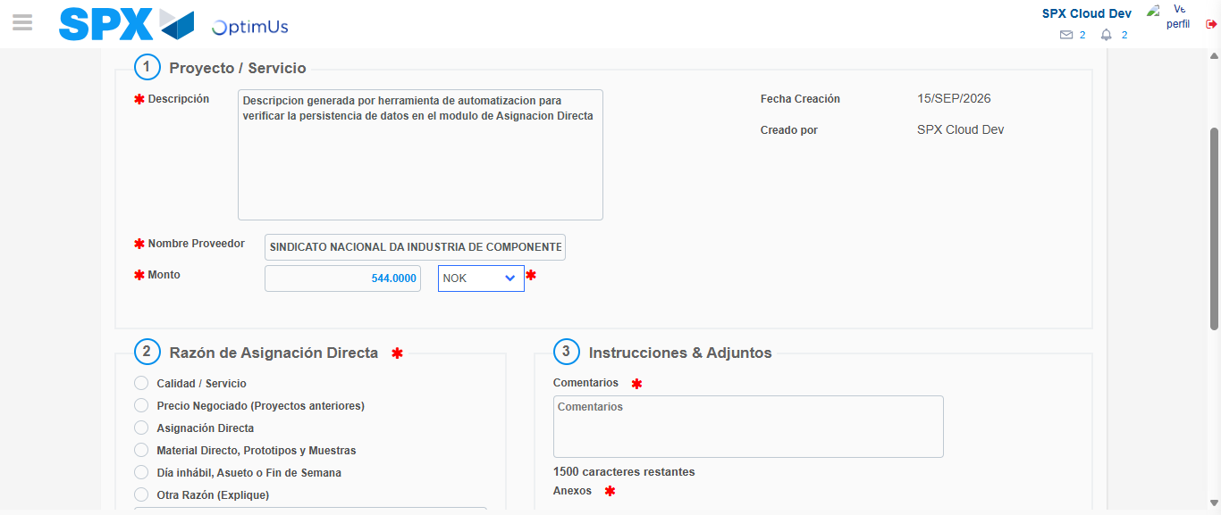Image file-name: QC_Testing-tc002_SPX_Dev5_Crear_Requisicion_Spot_Con_FAD_Tipo_Cobro_CC-1789485343541

Image file-name: QC_Testing-tc002_SPX_Dev5_Crear_Requisicion_Spot_Con_FAD_Tipo_Cobro_CC-1789485343751

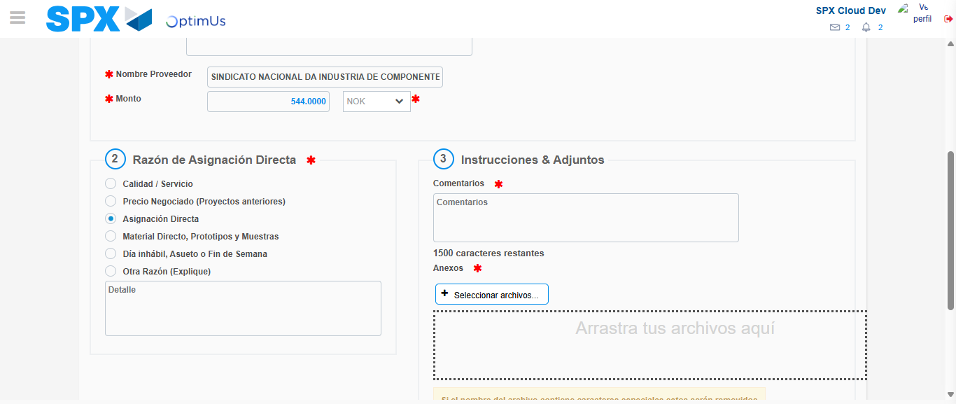Image file-name: QC_Testing-tc002_SPX_Dev5_Crear_Requisicion_Spot_Con_FAD_Tipo_Cobro_CC-1789485344679

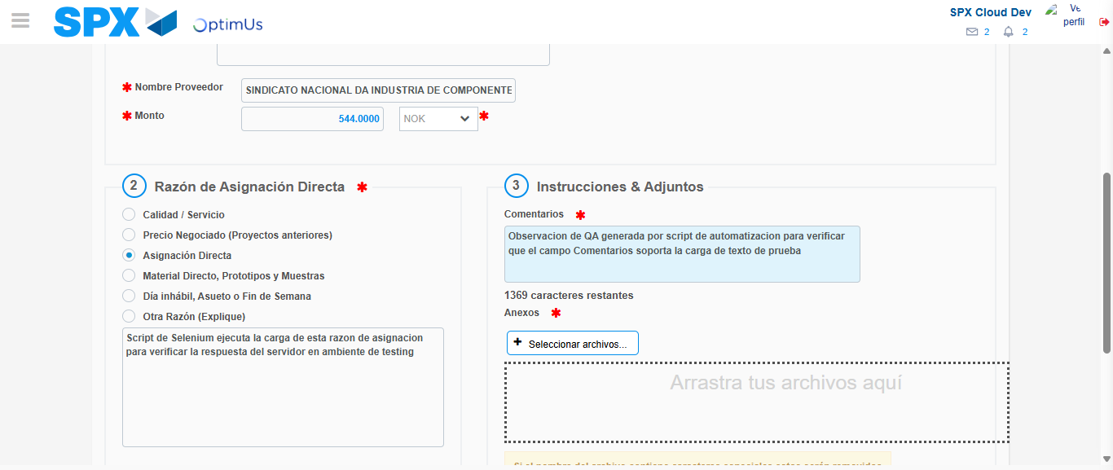Image file-name: QC_Testing-tc002_SPX_Dev5_Crear_Requisicion_Spot_Con_FAD_Tipo_Cobro_CC-1789485356064

Image file-name: QC_Testing-tc002_SPX_Dev5_Crear_Requisicion_Spot_Con_FAD_Tipo_Cobro_CC-1789485356770

Step 4 - Data Capture Spot Buy Requisition: Data captured correctly
Image file-name: QC_Testing-tc002_SPX_Dev5_Crear_Requisicion_Spot_Con_FAD_Tipo_Cobro_CC-1789485330311

Image file-name: QC_Testing-tc002_SPX_Dev5_Crear_Requisicion_Spot_Con_FAD_Tipo_Cobro_CC-1789485330514

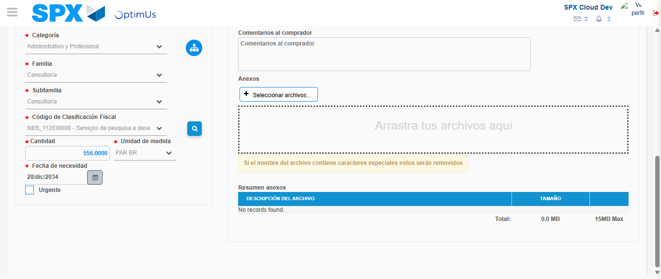Image file-name: QC_Testing-tc002_SPX_Dev5_Crear_Requisicion_Spot_Con_FAD_Tipo_Cobro_CC-1789485374469

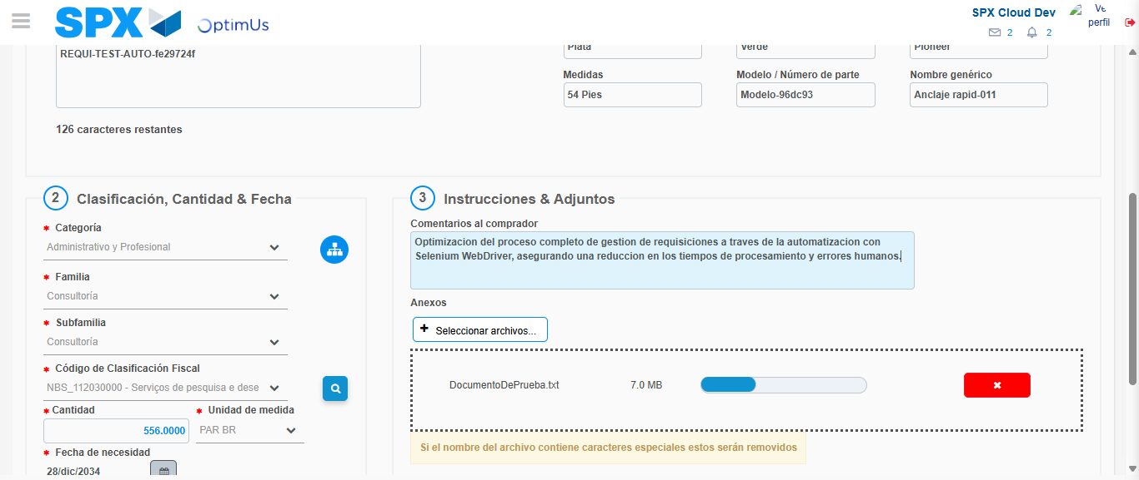Image file-name: QC_Testing-tc002_SPX_Dev5_Crear_Requisicion_Spot_Con_FAD_Tipo_Cobro_CC-1789485375388

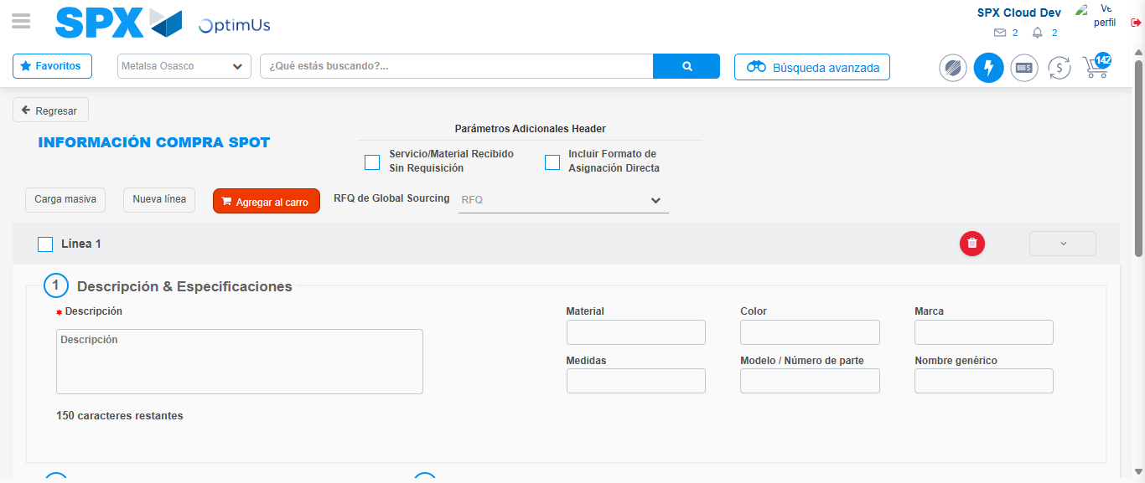Image file-name: QC_Testing-tc002_SPX_Dev5_Crear_Requisicion_Spot_Con_FAD_Tipo_Cobro_CC-1789485395510

Step 8 - Return to Main Page SPX : Return to Main Page SPX
Image file-name: QC_Testing-tc002_SPX_Dev5_Crear_Requisicion_Spot_Con_FAD_Tipo_Cobro_CC-1789485324635

Image file-name: QC_Testing-tc002_SPX_Dev5_Crear_Requisicion_Spot_Con_FAD_Tipo_Cobro_CC-1789485325210

Image file-name: QC_Testing-tc002_SPX_Dev5_Crear_Requisicion_Spot_Con_FAD_Tipo_Cobro_CC-1789485330016

Image file-name: QC_Testing-tc002_SPX_Dev5_Crear_Requisicion_Spot_Con_FAD_Tipo_Cobro_CC-1789485397771

Image file-name: QC_Testing-tc002_SPX_Dev5_Crear_Requisicion_Spot_Con_FAD_Tipo_Cobro_CC-1789485397943

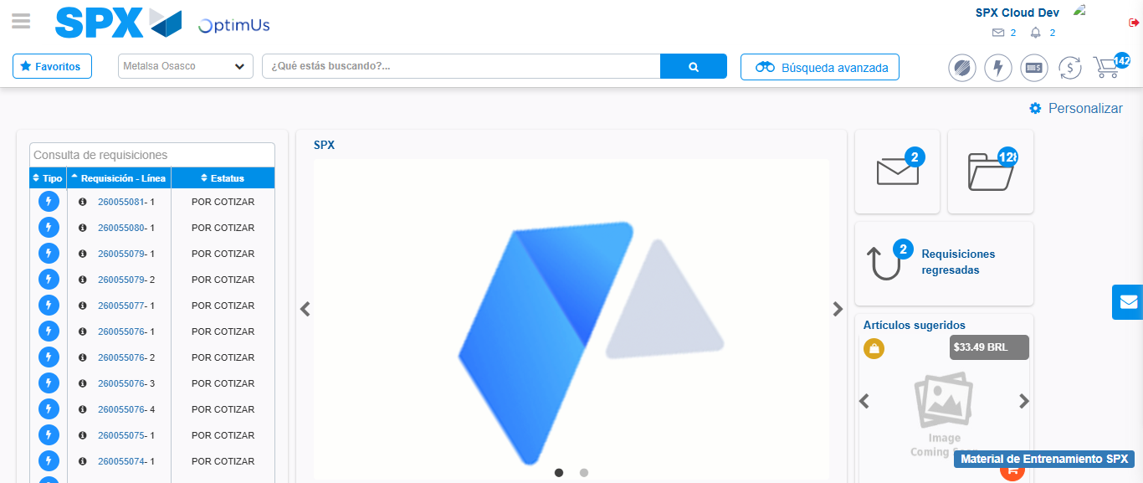Image file-name: QC_Testing-tc002_SPX_Dev5_Crear_Requisicion_Spot_Con_FAD_Tipo_Cobro_CC-1789485419163

Step 9 - Log Out : Log Out SPX
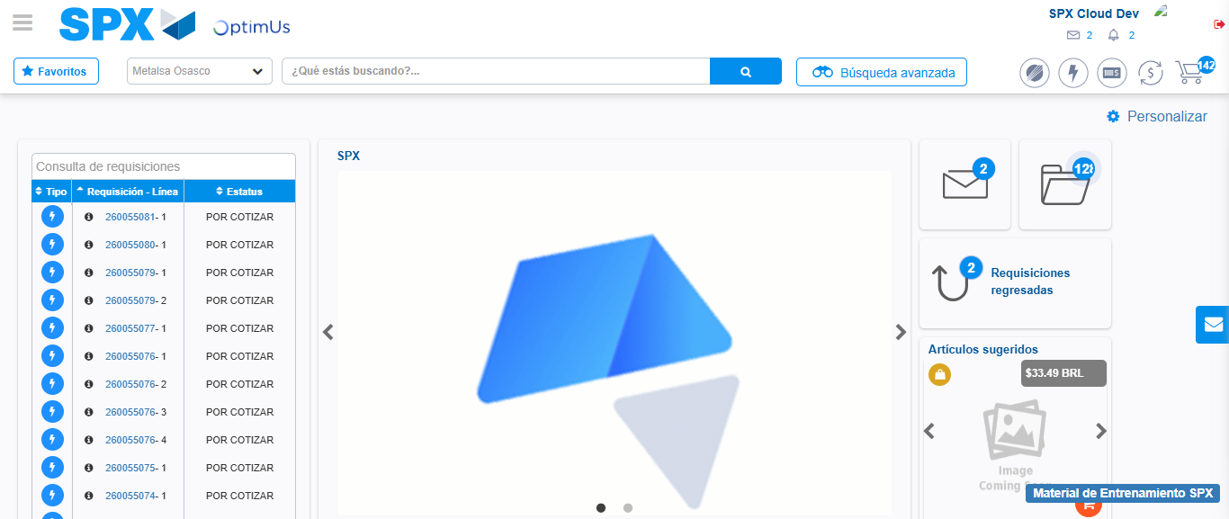Image file-name: QC_Testing-tc002_SPX_Dev5_Crear_Requisicion_Spot_Con_FAD_Tipo_Cobro_CC-1789485419522

